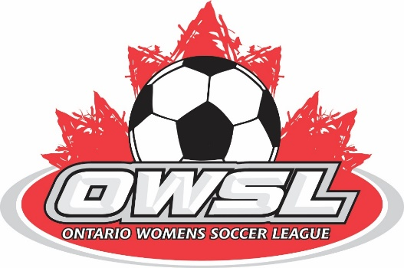

June 7, 2021

Ladies and gentlemen,
We are receiving numerous requests as to when the OWSL soccer season will start. Unfortunately, we cannot answer that at the present time.
We are all very encouraged the covid case numbers are reducing dramatically and the population is getting vaccinated to help reach the government goals for the “Steps” toward opening.
The OWSL is planning a soccer season this year and will start as soon as the Ontario government permits team and League play, along with Ontario soccer permitting us to start the return to play protocol. We do not know what the restrictions will be; number of participants at the field, number of participants per “bubble” if any, number of people per location, Provincial, Regional or district play…, etc, etc,

What we do know is that we will contact all teams and clubs once we are made aware by the Ontario Soccer and Ontario government what the plan to open is, and when each stage will take effect.

We recognize that 99% of our players have not kicked a ball in over a year, each team and every player requires 2 – 3 weeks preseason prep time as a team. We will give the OWSL teams this prep time to avoid unnecessary injuries.

Based on the current information, June 14th (or earlier) is when 10 players may begin to train while socially distanced. At least 21 days after step 1 begins, step 2 may take effect, which is when league play may be permitted. With this in mind, we are looking at a start sometime in mid-July or possibly sooner.

Thanks

Tony Crowle
OWSL President

