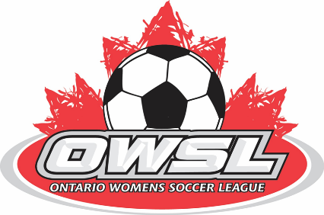

Good day Everyone,
After much discussion and emphasis on the well being and safety of our members, it is with heavy hearts the OWSL Board of Directors has made the difficult decision to cancel the 2020 outdoor soccer season.
We were hoping we would be able to provide some version of a league or tournament for the open age divisions. However, our review of the current information available and having realistic expectations, our conclusion is that this would not be feasible. Also, after reviewing the costs to our members to play for a small portion of the available season, it is not fair to those that can and those that wish to participate but cannot as their municipalities have closed their parks for the summer.
Furthermore, we received numerous notifications from teams advising us that they can no longer field a team as many players are unable to afford to play or do not feel its safe to return to a contact sport at this time.
With the current government guidelines, we will not be permitted to resume play until stage 3 of the government reopening of Ontario. As 90 % of our membership are in the more heavily populated areas and are still at stage 1 of reopening, we cannot see stage 3 of reopening being implemented until the end of the summer at the earliest.
We are monitoring all that is happening right now and will send out any important information as we receive it.
League fee’s will be refunded and will be sent out in the coming weeks.
Please stay safe and healthy, so we may all get back to the game we love,

Tony Crowle, OWSL President

